August 29th, 2010
Hi
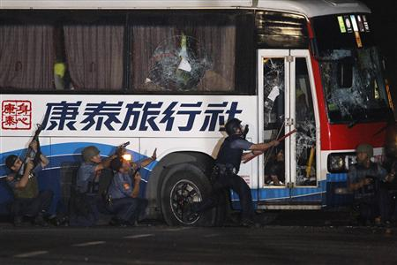
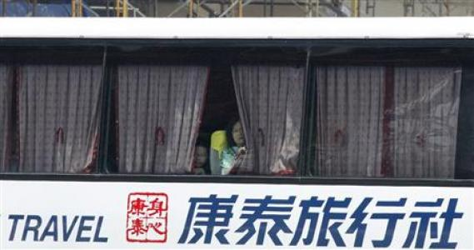
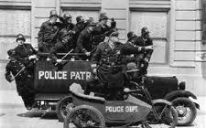
You will undoubtedly have heard of the hostage tragedy that affected Hong Kong last Monday, when a gunman in Manila, the capital of the Philippines, got onto a bus with 25 people, most of whom were Hong Kong tourists, and held them hostage for about 12 hours before ending with the deaths of the gunman and eight of the Hong Kong tourists. All this was broadcast live on TV in many parts of the world. In the evening, when I first heard of it, I was watching the drama unfold on both local TV and also on the BBC. Hong Kong has been in shock for the past week as, being a pretty safe city here, we don't think of these kinds of things happening. It was not nice watching it on TV particularly when the SWAT team decided to act. Really, it was was watching a re-run of an old 'Keystone Kops' movie. (Have you heard of the Keystone Kops? They were a bunch of hapless policemen who couldn’t do anything right. They were contemporaneous with the likes of Abbot and Costello and just as loony.) The particular thing that distressed me was seeing some of the people peeping out from behind the drawn curtains in the bus and then finding out later that they were dead (such as the lady in the picture). And yet I feel a lot of sympathy for the gunman who was a former policeman and claims he was unjustly sacked and that the justice authorities were not treating his case seriously. Also, some of the hostages later said that he was very calm and nice and that things only turned bad when the SWAT team got involved. Two of the hostages, who along with 8 others, including most children, had been released as the man had run out of diabetes medicine even said they thought of returning to the bus! The normally hapless HK government this time did almost everything right in offering help for the victims. Just a few hours after the incident, they sent a plane with medical, counselling teams, etc. over to Manila. The coffins of the victims together with most of the sueviving hostages returned to HK on Wednesday evening. Their arrival too was broadcast live on local TV. The next morning, at 8 am, at the normal flag-raising ceremony outside the Convention Centre, a three-minute silence was held and a lot of HK stopped for those minutes. There were also a number of protests against the Philippines' government. There was also a big concern of revenge against local Philippine amahs though this has not happened, most people realising that they had nothing to do with it and in fact were just as ashamed as HK people of the actions of their government. However, sad to say, several people sacked their amahs as a result. The following website has more photos on the hostage situation:
http://www.reuters.com/article/idUSTRE67M0DJ20100823

Did you hear about the monster traffic jam the other day on a highway leading into Beijing? It was 190 km long and lasted for nine days and stretched from Beijing all the way up into Inner Mongolia!! It was expected to last many days more but then ended quite quickly. It also spurned a mini roadside industry with locals selling food etc. to the people trapped – at, of course, inflated prices!
Also on Monday, my internet connection broke – again!!! However, this time a technician was able to come the next day to 'fix' it. The problem is the same – wiring in the building.
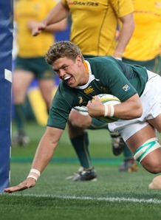
Gavin tried to call on Skype a few minutes after the connection had been fixed but for some reason I was not here. I read somewhere the other day that people with gmail can, for a limited time, use PC to phone to almost anywhere in the world for free.
In South Africa yesterday, the Springboks beat the Wallabies 44-31 in a late comeback. So , with just one game remaining (between NZ and Aus), NZ has 5 wins (out of 5 tests) while the Springboks and Wallabies have just one apiece. In England, NZ and Australia have reached the semi-finals in the Women's Rugby World Cup.
I mentioned about complaining to the NZ Department of Internal Affairs about them charging me a courier fee to send my new passport when I had not requested it. The person I contacted via e-mail about this flatly refused to refund the fee, so I told her her reply was unsatisfactory and to send it to a higher official, which she did. Well, I got the fee refunded, and to my credit card account. I asked them not to send a cheque as the cost of cashing the cheque would eat up most of its value. There was also a bit of correspondence between myself and this official in which I made a number of comments and suggestions. The problem with the courier fee was due to ambiguous wording in the application form – the form gives you the choice to use the courier service or not when in fact there is no choice! I pointed this out and suggested how the form could be reworded; he agreed and says they will modify the form. I also suggested that, as passports are now only valid for a maximum of 5 years and many travellers have to renew them after about 4 years, they should renew the passport from the date of expiry of the old passport, as is done with credit cars, driving licences, etc., rather than the date the application is processed. This would save the hassle of having to renew passports so often. (In the 'old' days, with 10-year passports, renewing after 9 years was not so bad.) Under present legislation however, this cannot be done. I also pointed out that the covers of the new passports curl up when left in the open which never happened with previous passports. They are aware of this problem.
That’s about it for this week.
Cheers

